Panopto Student Guide – Recording or uploading videos to an
assignment folder using Panopto - Students

Overview
This user guide takes you through the process of recording or uploading a video, as a student,
to an Assignment Folder that has been setup by your lecturer in Brightspace.
Notes:
- Before being able to record to Panopto, your lecturer/tutor must have enabled the
Assignment Folder feature in your module in Brightspace.
- Any recording uploaded to the ‘Assignment Folder’ will be private to yourself and your
university lecturer(s)/tutor(s). By default, your fellow students will not be able to view
your recordings.
- Please bear in mind that video files tend to be large in size and therefore will take time
to upload to the server. Make sure you give yourself sufficient time for possible delays
uploading large video files so as not to miss any submission deadlines.
How do I create/upload a recording?
Once your lecturer has created an assignment folder you will be able to access the assignment
folder from within Brightspace and then decide whether you wish to use the recording tools provided by Panopto to record your video or simply upload a video that you have already recorded.

How to record/upload a video to your assignment folder.
- Login to Brightspace https://learn.ul.ie/
- Select you Brightspace site.
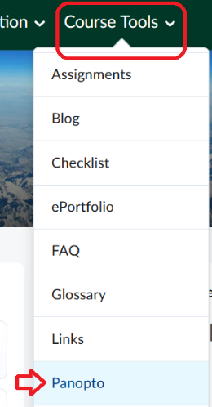
- Select Panopto from the top menu bar – Course Tools > Panopto

Figure 1 Panopto tool

- Click on the student assignment folder. (Please note your lecturer should specify the name of this folder).

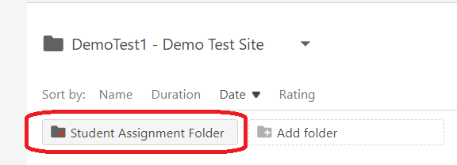
Figure 2 Student Assignment folder

- Press the green Create button.
Figure 3 Create button

- Choose from one of three options (see full instructions below).
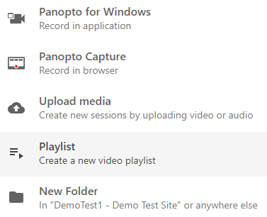

Figure 4 Create Options

- Select Panopto for Windows (Record in application) if you wish to use the Panopto recorder to create your video presentation. (First time users will need to download and install this tool).
- Select Panopto Capture (Record in browser) to use the Panopto lightweight capture tool to record directly from your browser (no install required.)
- Select Upload Media if you have simply wish to upload a video that you have already recorded.

- Once your video is uploaded you can edit it online using the Panopto edit tool.
Please note: Please ensure that you upload your recording to the correct assignment
folder, as this will ensure that your lecturer(s) can access your work.

Recording and Upload Options.
Once you have logged into your assignment folder in Brightspace you can choose one of the following three options (see figure 5 below).

- Panopto for Windows.
- Panopto Capture.
- Upload media.

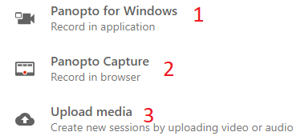
Figure 5 Record or Upload Media

Option 1. Record a new session.
If you decide to use Panopto recorder to Record a new session, you will be prompted to either Open
Panopto if you have already installed it or else to download it to install it. Once it is
installed, press Open Panopto to launch the Panopto recorder.
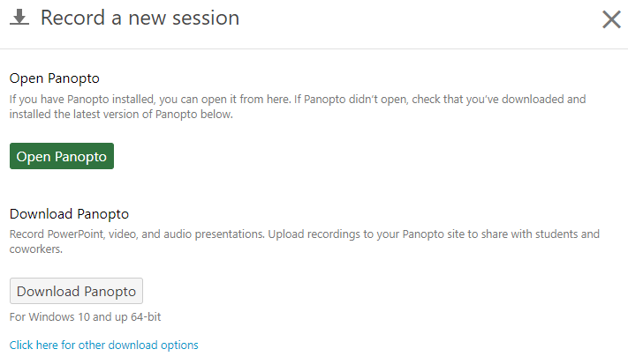
Figure 6 Launch Panopto or Download Panopto

Panopto Recorder: Settings
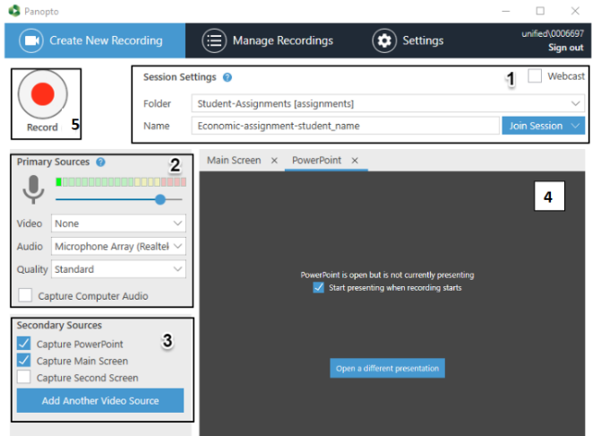

Figure 7 Panopto Recorder

1: Session Settings
Use the Session Settings area of the recorder to specify your Folder and session Name.
It is essential you select the correct assignment recording folder, as this will ensure that your
module tutor(s) can access your work. Contact your module lead if you are unable to access to
your assignment folder.

Select the Folder drop-down list then click the relevant folder/module name:
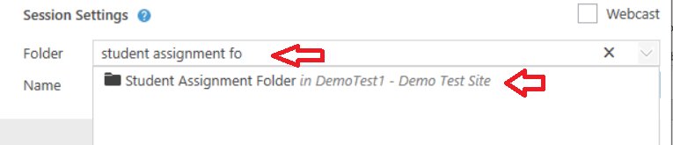
Figure 8 Assignment Folder
Assignment folders are identifiable by the [assignments] suffix.
Once selected, your recording will be stored in this cloud folder. The recording will be
restricted so that only you and your module tutor(s) can access it.
Figure 4. Panopto Recorder
After selecting the correct folder, enter a Name for your recording. You can amend the name
later, if required.

2: Primary Sources
Use the Primary Sources panel to select the Video and Audio inputs for your recording:
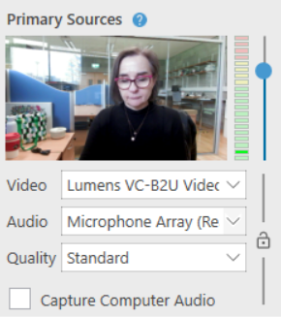
Figure 9 Primary Sources Panel
Select your Video input, for example Lumens VC-B2U Video webcam, from the drop-down menu. If
you do not want to capture video, select None.
Select your Audio input, for example the webcam microphone, from the drop-down menu. Audio is required for every recording.
Important: Ensure you adjust the input volume using the blue slider. For best results, the volume indicator should reach the top of the green section when presenting.
The Quality drop-down should be set as High in most instances. Higher quality settings are available.
If you are recording your screen and would like to capture related audio, select the Capture Computer Audio box.

3: Secondary Sources
Use the Secondary Sources panel to select any additional inputs for your recording:
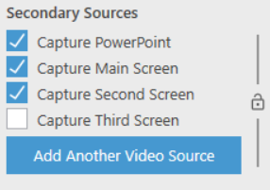
Figure 10 Secondary Sources
Select Capture PowerPoint if you would like to include PowerPoint slides in your recording.
Viewers will be able to view and navigate through the slides, in time with your audio/video.
Select Capture Main Screen to record any content on your main monitor. Example use cases include
recording software or website demonstrations.
If you have a second monitor, you will also have the option to Capture Second Screen.
We recommend you capture both PowerPoint and the Main Screen.
4: PowerPoint Tab.
To include PowerPoint in your presentation, please open it on your pc.
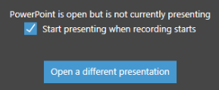
Figure 11 PowerPoint Presentation
The Start presenting when recording starts option will put your PowerPoint slides into presenter mode, as soon as you click Record.
If you need to open a different PowerPoint presentation, click Open a different presentation.
5: Recording your presentation
Once you have configured the recorder and opened your PowerPoint presentation (if required),
you can begin recording.

- From the top-left hand corner of the recorder, click Record to start. Alternatively, you
can use the F8 shortcut key to start recording.
- Deliver your presentation and proceed through your PowerPoint slides and/or
software demonstration, if applicable. You can return to the recorder to Pause (F9) the
recording, and Stop (F10), when completed.
- After stopping the recording, the Recording Complete message appears
- If you are happy with the recording, press Done. To delete the recording, click Delete and
record again.
Note: The upload procedure may take some time to complete. Panopto will provide you with
instructions to let you know when it is safe to close your browser window.
Further details on how to record a session using Panopto Recorder at the following links:
Windows PCs: https://support.panopto.com/s/article/basic-recording-1
For Mac: https://support.panopto.com/s/article/Recording-with-Panopto-for-Mac
Option 2: Using Panopto Capture Tool

Panopto Capture allows a user to easily record audio, video, and entire screens, or application
windows. A user can access Panopto Capture from directly within their browser, and no
download is required.
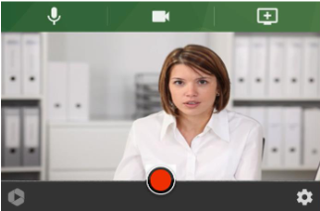
Figure 12 Panopto Capture Tool
Full details on how to use Panopto Capture are available at this link:
https://support.panopto.com/s/article/How-to-Create-a-Video-Using-Panopto-Capture

Option 3: Upload Media.
You can upload a previously created video using the Upload Media tool.
First select your assignment folder, then select the files you wish to upload, and your files will start
uploading to the assignment folder
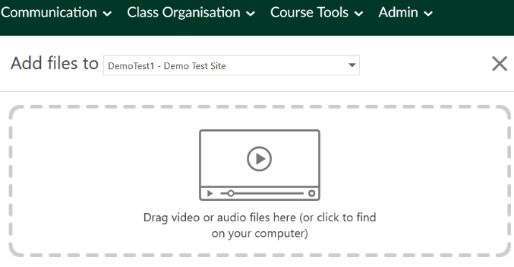
Figure 13 Upload media tool
Once your files are uploaded you will see a notice that “Upload Complete. You can close this window
now.”
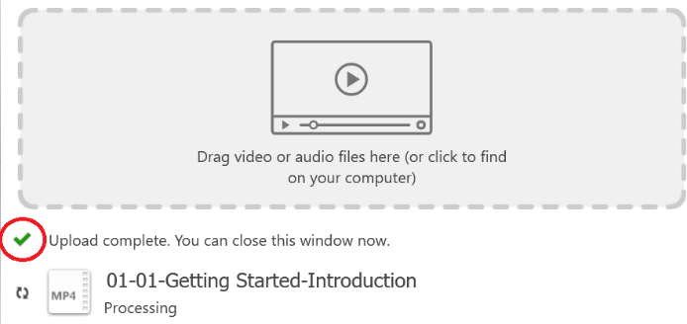
Figure 14 Upload complete screen
Once your files are uploaded you can edit them online using the Panopto edit tool.
Further instructions are available at this link:
https://howtovideos.hosted.panopto.com/Panopto/Pages/Viewer.aspx?id=bf2e77af-d26d-4f73-b479-aaa30106b245

Panopto Mobile App
Please note it is also possible to use the Panopto mobile App for IOS & Android to record and upload
media to an assignment folder. Once you have the App downloaded you can login to it using your
UL Student email address and password.
Full instructions with regard to using the mobile app are available here:
https://support.panopto.com/s/article/How-to-Use-the-Panopto-Mobile-App
Please ensure that you upload your video to the correct assignment folder. If your assignment
folder is not available, please contact your module lead.
The address of the UK Panopto server if required is https://ulcampus.cloud.panopto.eu/
Please note to access the Panopto server you do need a valid UL student account.
We hope that you have found this student user guide useful.
Embed code if needed for website.
<iframe
src="https://ulcampus.cloud.panopto.eu/Panopto/Pages/Embed.aspx
?id=fcb6c49f-5a1d-4e78-ae32-
ac56011f0a95&autoplay=false&offerviewer=true&showtitle=true&sh
owbrand=false&start=0&interactivity=all" height="405" width="720"
style="border: 1px solid #464646;" allowfullscreen
allow="autoplay"></iframe>

