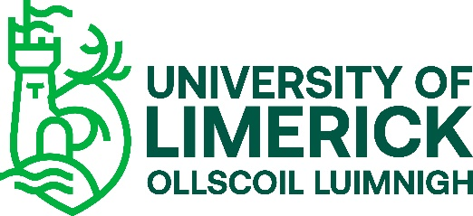

FACULTY OF EDUCATION AND HEALTH SCIENCES
RESEARCH ETHICS COMMITTEE (EHSREC)
Ethical Consent Form
I, the undersigned, declare that I am willing to take part in research for the project entitled
“INSERT Name of Research Project”.
- I declare that I have been fully briefed on the nature of this study and my role in it and have been given the opportunity to ask questions before agreeing to participate.
- The nature of my participation has been explained to me, and I have full knowledge of how the information collected will be used.
- I am aware that my participation in this study will be audio/video recorded and I agree to this. However, should I feel uncomfortable at any time, I can request that the recording software be switched off.
- I am aware that such information may also be used in future academic presentations and publications about this study.
- I fully understand that there is no obligation on me to participate in this study.
- I fully understand that I am free to withdraw my participation without having to explain or give a reason, up to a period of two weeks after the data collection is completed.
- I know that I have been asked not to discuss the content of the focus group discussion, or the identity of its participants with anyone.
- I acknowledge that while the researcher has asked all focus groups participants to maintain confidentiality in the above manner, the researcher cannot guarantee that individual participants will adhere to this request.
- I acknowledge that the researcher does guarantee that they will not use my name or any other information,that would identify me in any outputs of the research.
- I declare that I have read and fully understand the contents of the Research Privacy Notice.

______________________________________ __________________________
Signature of Participant Date
______________________________________ __________________________
Signature of Investigator Date
Yes | No
Consent to Contact about Similar Future Research
I explicitly consent to the University contacting me as part of current or similar future research and holding my contact details on its database for the purpose of contacting me.

