Panopto – Recording and Upload Options – Upload Media
You can upload a previously created video using the Upload Media tool.
First select your assignment folder, then select the files you wish to upload, and your files will start
uploading to the assignment folder
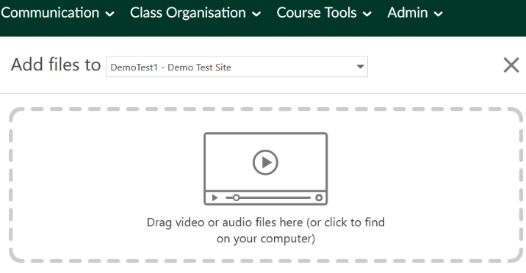
Figure 1 Upload media tool
Once your files are uploaded you will see a notice that “Upload Complete. You can close this window
now.”
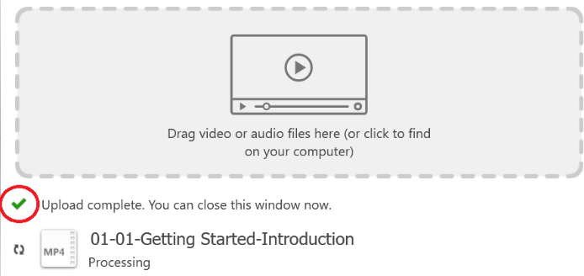
Figure 2 Upload complete screen
Once your files are uploaded you can edit them online using the Panopto edit tool.
Further instructions are available at this link:
Getting Started – Edit a Video

Panopto Mobile App
Please note it is also possible to use the Panopto mobile App for IOS & Android to record and upload
media to an assignment folder. Once you have the App downloaded you can login to it using your
UL Student email address and password.
Full instructions with regard to using the mobile app are available here:
How to Use the Panopto Mobile App
Please ensure that you upload your video to the correct assignment folder. If your assignment
folder is not available, please contact your module lead.
The address of the ul Panopto server if required is https://ulcampus.cloud.panopto.eu/
Please note to access the Panopto server you do need a valid ul student account.

