Recording and Upload Options – Record a new session
If you decide to use Panopto recorder to record a new session, you will be prompted to either Open
Panopto if you have already installed it or else to download it to install it. Once it is
installed, press Open Panopto to launch the Panopto recorder.
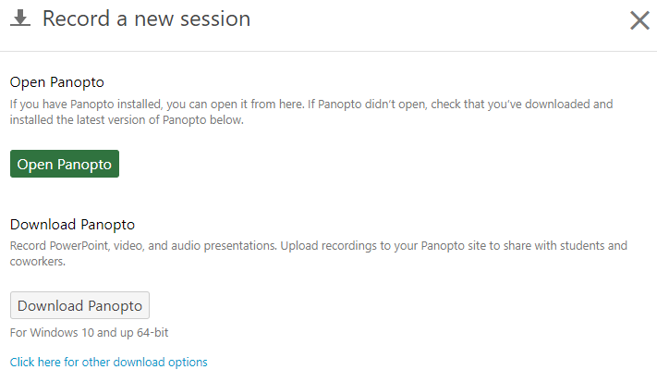
Figure 1 Launch Panopto or Download Panopto

Panopto Recorder: Settings
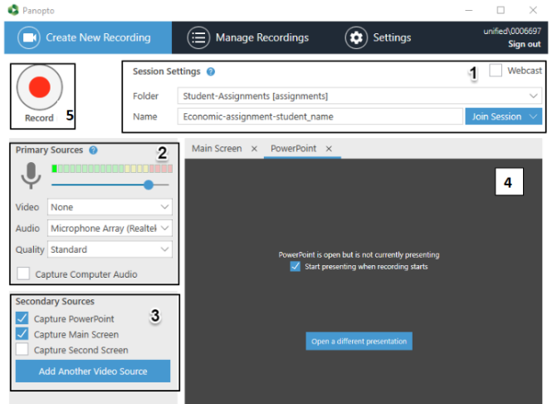

Figure 2 Panopto Recorder

1: Session Settings
Use the Session Settings area of the recorder to specify your Folder and session Name.
It is essential you select the correct assignment recording folder, as this will ensure that your
module tutor(s) can access your work. Contact your module lead if you are unable to access to
your assignment folder.
Select the Folder drop-down list then click the relevant folder/module name:
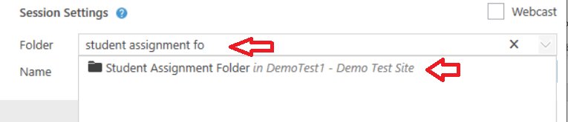
Figure 3 Assignment Folder
Assignment folders are identifiable by the [assignments] suffix.
Once selected, your recording will be stored in this cloud folder. The recording will be
restricted so that only you and your module tutor(s) can access it.
Figure 4. Panopto Recorder
After selecting the correct folder, enter a Name for your recording. You can amend the name
later, if required.

2: Primary Sources
Use the Primary Sources panel to select the Video and Audio inputs for your recording:
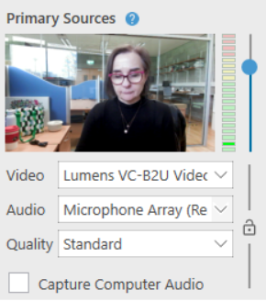
Figure 4 Primary Sources Panel
Select your Video input, for example Lumens VC-B2U Video webcam, from the drop-down menu. If
you do not want to capture video, select None.
Select your Audio input, for example the webcam microphone, from the drop-down menu. Audio is required for every recording.
Important: Ensure you adjust the input volume using the blue slider. For best results, the volume indicator should reach the top of the green section when presenting.
The Quality drop-down should be set as High in most instances. Higher quality settings are available.
If you are recording your screen and would like to capture related audio, select the Capture Computer Audio box.

3: Secondary Sources
Use the Secondary Sources panel to select any additional inputs for your recording:
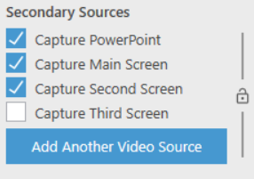
Figure 5 Secondary Sources
Select Capture PowerPoint if you would like to include PowerPoint slides in your recording.
Viewers will be able to view and navigate through the slides, in time with your audio/video.
Select Capture Main Screen to record any content on your main monitor. Example use cases include
recording software or website demonstrations.
If you have a second monitor, you will also have the option to Capture Second Screen.
We recommend you capture both PowerPoint and the Main Screen.
4: PowerPoint Tab.
To include PowerPoint in your presentation, please open it on your pc.
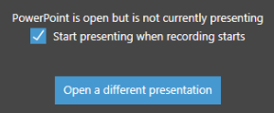
Figure 6 PowerPoint Presentation
The Start presenting when recording starts option will put your PowerPoint slides into presenter mode, as soon as you click Record.
If you need to open a different PowerPoint presentation, click Open a different presentation.
5: Recording your presentation
Once you have configured the recorder and opened your PowerPoint presentation (if required),
you can begin recording.

- From the top-left hand corner of the recorder, click Record to start. Alternatively, you
can use the F8 shortcut key to start recording.
- Deliver your presentation and proceed through your PowerPoint slides and/or
software demonstration, if applicable. You can return to the recorder to Pause (F9) the
recording, and Stop (F10), when completed.
- After stopping the recording, the Recording Complete message appears
- If you are happy with the recording, press Done. To delete the recording, click Delete and
record again.
Note: The upload procedure may take some time to complete. Panopto will provide you with
instructions to let you know when it is safe to close your browser window.
Further details on how to record a session using Panopto Recorder at the following links:
Windows PCs: https://support.panopto.com/s/article/basic-recording-1
For Mac: https://support.panopto.com/s/article/Recording-with-Panopto-for-Mac

