Cooperative Education & Careers Division

Instructions for completion of Pre and Post Cooperative Education Forms

Before completing the forms | Before completing the forms, please select the following link: https://www.ul.ie/cecd/students/reflective-assessment. This introduces the Learning During Coop section, lists and describes the skills to be assessed, explains how best to approach the forms, and outlines the role of the forms as part of Coop Assessment.
Accessing the forms | Please access the relevant form using the following instructions:  For the Pre-Coop form, open the following link: https://www.ers.ul.ie/coop/coop/students/pre_coop_skills.php  For the Post-Coop form, open the following link: https://www.ers.ul.ie/coop/coop/students/post_coop_review.php
Signing up to the form | Before completing the forms, you must sign-up on the website. When you access the forms initially, entry fields for an ID Number and password display, as shown in Figure1.  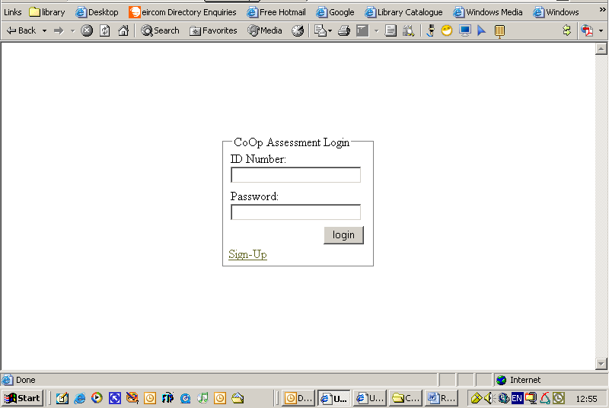  Figure 1: Screenshot showing webpage where students enter their ID Number and Password.  - To create your account, select the Sign-Up link.  - A Sign-Up option is displayed, as shown in Figure 2. Enter your Student ID Number, Password (please assign your own password), and email to which you want your password to be sent as a reminder.  - Select OK.  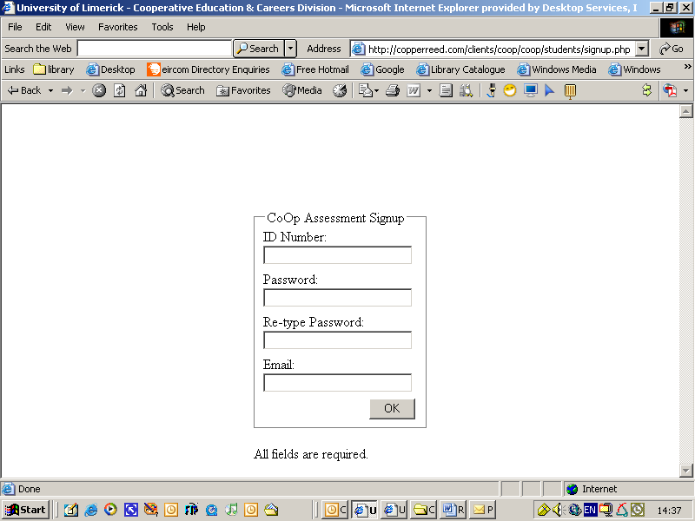  Figure 2: Screenshot showing webpage with Sign-Up fields  Your password will be sent to the email address you provide; please note that this may not reach your account immediately, and so it is advisable to make note of your password elsewhere.  After you have signed up, you will be prompted for your ID Number and password each time you access this section.  Note: Should you need to reset your password, the system will reset and forward to you an automatically-generated password. Select the following link to use this facility: https://www.ers.ul.ie/coop/coop/students/resetpassword.php
Completing the form | When you log-in to the form, a page of instructions displays, as shown in Figure 3. Please read through the instructions before you begin to complete the form. To proceed to the next screen, select the ‘Next’ option.  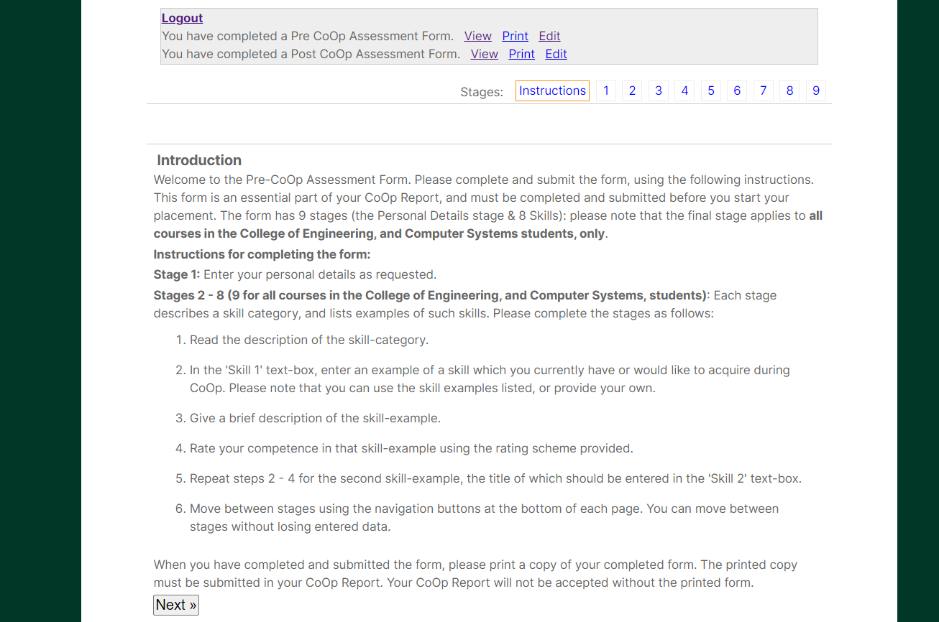  Figure 3: Screenshot of webpage listing instructions for form completion.
Entering personal details | The Personal Details screen displays, as shown in Figure 4.  - Please complete the required fields. Please note that each field must be filled.  - To proceed to the next screen, select the ‘Next’ option.  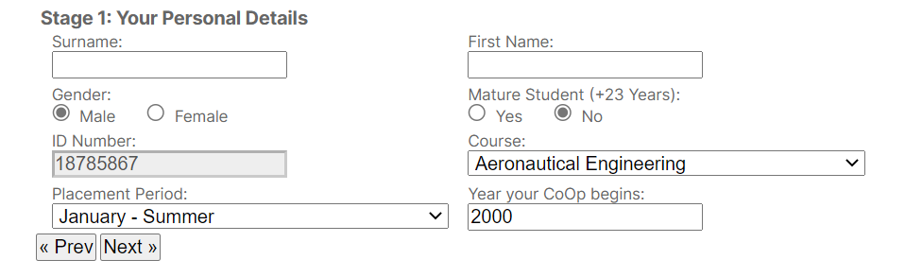  Figure 4: Screenshot of webpage showing entry fields for personal details.
Completing the 7 or 8 skills | Each skill must be completed. Please read the overview of the skill category, and the skills examples, as shown in Figure 5.  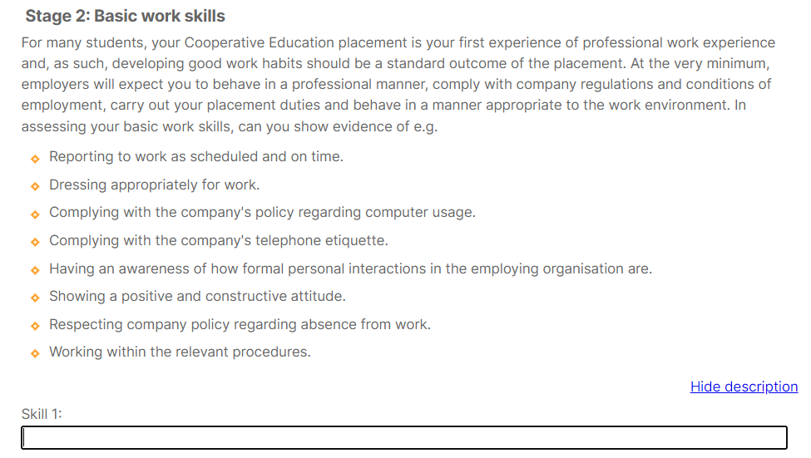Figure 5: Screenshot showing sample of skill category i.e. overview and samples.  - In the 'Skill 1' text-box, enter an example of a skill which you currently have or would like to acquire during Coop. Please note that you can use the skill examples listed, or provide your own.  - Give a brief description of the skill-example.  - Rate your competence in that skill-example using the rating scheme provided.  - Repeat steps 2 - 4 for the second skill-example, the title of which should be entered in the 'Skill 2' text-box.  - To proceed to the next screen, select the ‘Next’ option.
Moving between skill categories | Move between stages using the navigation buttons at the bottom of each page. You can move between stages without losing entered data.
Submitting the form | After completing the relevant number of skill categories, submit the form by selecting ‘Submit’ at the end of Stage 7 (for non Engineering and Computer Systems) or 8 (for Engineering and Computer Systems), as shown in Figure 6.  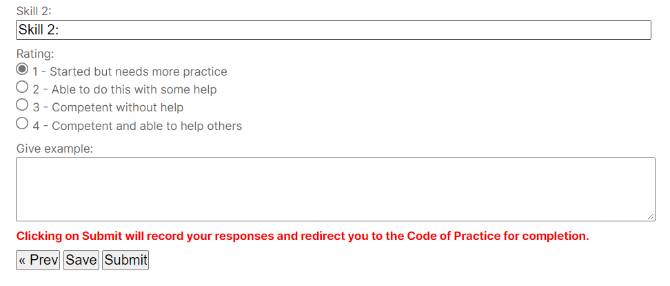  Figure 6: screenshot showing webpage with ‘Submit’ option i.e. Stage 7 or 8.
Printing the form | Immediately after submitting the form, a summarised, printable version displays. Please print and retain the form for submission as part of your Coop Report.
Editing / accessing the form | You may access or edit the submitted form by logging in using your ID Number and password. By editing and resubmitting the form, you replace the original form with your latest version.
Logging out of the form | When you are exiting the form, please select the ‘Logout’ link on the top left of any stage.

